

USE CASE dIAGRAM

[Document subtitle]



[Date]

[Company name]

[Company address]

|  |  |
| --- | --- |
| Name | ID |
| Farida Mahmoud  (team leader) | **20210278** |
| Reaal Mohamed | **20214167** |
| Maickel Ezzat | **20194184** |
| Mohamed Fares | **20200521** |

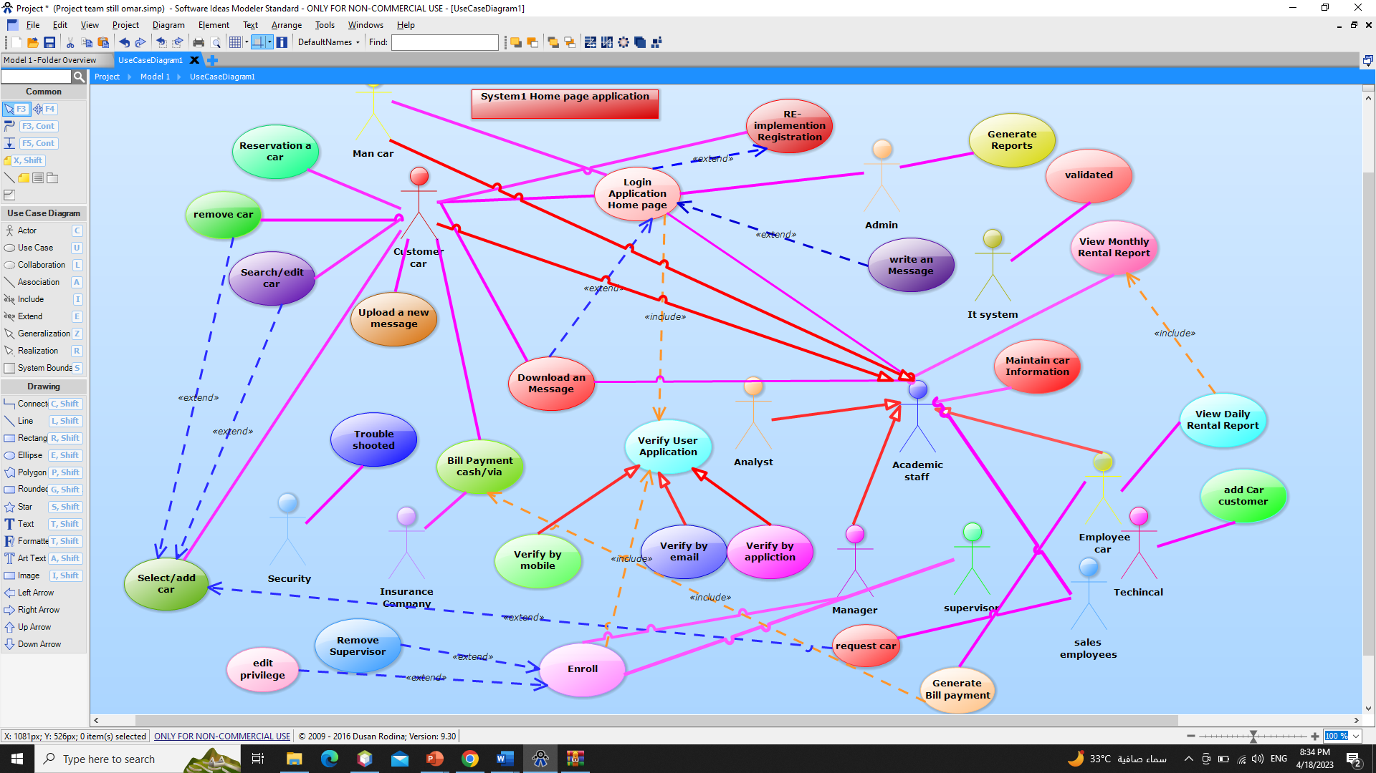

|  |  |  |
| --- | --- | --- |
| Use case Id | 1 | |
| Use Case Name | | Create a message or notes about the car. |
| Response | | The message will be available in the customer’s car. |
| Precondition | | The user successfully login to the system |
| Actors | | All Academic Staff Members and Admin and Man Car. |
| Input data | | User name, Password, ID Car & ID customer. |
| Description | | The academic staff member will create and message by pressing the create message button. Then he or she will enter the data (due date, number of attached files, reports cars, id, password, email).then he or she will press view to customers or he or she can hide a message to customers. |

USE CASE TABLE

Scenario table

|  |  |
| --- | --- |
| Scenario ID | 1.2 |
| Scenario Name | Fail login |
| Target Use Case | login |
| Scenario Events | The customer “Reaal” has the Password “Reaal1234”.she will log in by entering this data and username” Reaal”&  Password” REAAL1234”.then she press login & enter the verification code”123” and then a fail message appeared” User Name or Password or id” is wrong. |

ADD CAR

|  |  |
| --- | --- |
| Use case id | 1 |
| Use case name | Add car |
| Actors | Insurance company manager , Insurance company employer , Analyst , Man car employer , Customer Service |
| Precondition | New car contract with the insurance company |
| Input Data | The car’s license and an affidavit stating that the car’s price is more than 50,000 and that it is more than five years old. |
| Flow Of Event | The customer fills in the data and reads the conditions, such as (the card and the car license). The analyst and the owner of a car business confirms the age of the car and its price because it matches the conditions, such as (the age did not exceed five years and its price was not less than fifty thousand). In the event that the car does not meet the required conditions, the customer’s car insurance will be refused |
| Response of output | The car is insured or Tim refuses to insure the car |
| include | All the required data related to the car and the customer |
| Non-Function Requirements | In the event that the car does not meet the required conditions, the customer’s car insurance will be refused |
| Comment And Exception | N/A |

REMOVE CAR

|  |  |
| --- | --- |
| Use case id | 2 |
| Use case name | Remove car |
| Actors | Customer Service |
| Precondition | Car insurance cancellation |
| Input Data | Login to the insurance company's website , click on the icon for the car to be cancelled , cancel ,  Fill in the required data attach the documents |
| Flow Of Event | The customer cancels the insurance by going to the company’s headquarters or through the site, he enters his data and the car, and he chooses to cancel, and at the same moment the insurance is canceled either from the company’s headquarters, which is to go to customer service and enter the required data and cancel the insurance |
| Response of output | Insurance cancellation |
| include | Data pertaining to the customer and the car |
| Non-Function Requirements | In the event of incomplete data relating to the customer and the car |
| Comment And Exception | N/A |

EDIT CAR

|  |  |
| --- | --- |
| Use case id | 3 |
| Used case name | Edit car |
| Actors | Customer Service |
| Precondition | Change in car’s data |
| Input Data | Change in car’s data |
| Flow Of Event | Enter all information about the car |
| Response of output | Edit car’s data |
| include | car’s data |
| Non-Function Requirements | Car’s data is incomplete |
| Comment And Exception | N/A |

REQUEST CARS

|  |  |
| --- | --- |
| Use case id | 4 |
| Use case name | Request car |
| Actors | Insurance company manager , Customer, Insurance company employer , Sales employee ,  Customer service , Analyst , Man car employer |
| Precondition | Examination of the car or a video of the accident in which the car was affected |
| Input Data | Video of the accident or a report on the condition of the car |
| Flow Of Event | In the event that the car was in the insurance company and the car was affected by a major accident, the insurance company witnesses the incident or writes a report on the condition of the car. If the car must be replaced by another car, the insurance company gives the customer a text of a new car |
| Response of output | Half of the price of a new car paid by the insurance company |
| Non-Function Requirements | If the insurance was able to repair the car in this case, half of the price of a new car was not paid |
| Comment And Exception | N/A |

ADD CAR

|  |  |
| --- | --- |
| Scenario id | 1 |
| Scenario name | Add car |
| Target use case | Add car successfully |
| Scenario event | The customer add the data of car license "12723548286" and Analyst will know that the age of car “more than 5 years “ and his cost “more than 50.000” . after that the add will success |

|  |  |
| --- | --- |
| Scenario id | 1 |
| Scenario name | add car |
| Target use case | Add car is failed |
| Scenario event | If the customer write the car license wrong ”12723548365” or if the analyst know that the car his age neither “more than 5 years “ nor cost “more than 50.000” . after that the add will success |

REMOVE CAR

|  |  |
| --- | --- |
| Scenario id | 2 |
| Scenario name | remove car |
| Target use case | Remove car successfully |
| Scenario event | The customer add the data of car license "12723548286" |

|  |  |
| --- | --- |
| Scenario id | 2 |
| Scenario name | Remove car |
| Target use case | Remove car is failed |
| Scenario event | The customer add the data of car license "12723548286" or The customer add the data of car license but Wrote wrongly "127235089879" |

Edit car

|  |  |
| --- | --- |
| Scenario id | 3 |
| Scenario name | Edit car |
| Target use case | Edit car successfully |
| Scenario event | If the customer need to edit the data of the car  car license from “ 122748358974” to “343556557” |

Request car

|  |  |
| --- | --- |
| Scenario id | 4 |
| Scenario name | Request car |
| Target use case | Request car successfully |
| Scenario event | The customer takes pictures of the accident that happened to the car, but the car is not repaired  The insurance company will pay half of the car price 200,000 |

|  |  |
| --- | --- |
| Scenario id | 4 |
| Scenario name | Request car |
| Target use case | Request car is failed |
| Scenario event | The customer takes pictures of the accident that happened to the car, and if the car will be repaired |

|  |  |
| --- | --- |
| Use Case Name | Login |
| Precondition | **Customer Open The Application** |
| Description | **The system actor will enter the user name and password, after which the user will press the login button, and the verification procedure will be completed successfully. The user will be returned to his home page. In addition, if the verification method fails and the user name and password are invalid, the user will receive an error message.** |
| Response | **Home page for the user or a failure message** |

|  |  |
| --- | --- |
| Use Case Name | Winch |
| Precondition | **Customer Opens the Application** |
| Description | **The first client accesses the application, wants a winch request, provides the spot, and the employee asks the insurance company to need a winch for a customer since the automobile broke down on the road.** |
| Response | **Response of an insurance company to a customer.** |

|  |  |
| --- | --- |
| Use Case ID | 1 |
| Use Case Name | Enroll Car’s Management Head |
| Actors | Manager |
| Precondition | Manager open the application. |
| Input Data | Email, Username and Password. |
| Description | The manager will enter his email, username and password and press the enroll button after the verification is done successfully the manager will enter his homepage or the manager will receive an error message if any information is wrong. |
| Response | Manager homepage or error message. |
| Comments & Exceptions | - |
| Use Case ID | 2 |
| Use Case Name | Enroll Supervisor |
| Actors | Supervisor |
| Precondition | Supervisor open the application. |
| Input Data | Email, Username and password. |
| Description | The supervisor will enter his email, username and password and press the enroll button after the verification is done successfully the supervisor will enter his homepage or he will receive an error message if any information is wrong. |
| Response | Supervisor homepage or error message. |
| Comments & Exceptions | - |

|  |  |
| --- | --- |
| Use Case ID | 3 |
| Use Case Name | Edit supervisor’s privileges |
| Actors | Supervisor |
| Precondition | Supervisor open the application. |
| Input Data | Supervisor’s personal information like name, age, email and his role. |
| Description | Add supervisor’s privileges, edit or remove supervisor’s privileges depending on the supervisor’s performance like if he worked overtime, he could get increased salary. |
| Response | Type of privilege added, removed or edited. |
| Comments & Exceptions | - |

|  |  |
| --- | --- |
| Use Case ID | 4 |
| Use Case Name | Remove Supervisor |
| Actors | Supervisor, Managers. |
| Precondition | Manager open the application. |
| Input Data | Manager username and password. |
| Description | If the manager wants to remove a supervisor for a specific reason, he can open the application and remove the supervisor then delete his information from the system. |
| Response | Supervisor dismissal. |
| Comments & Exceptions | - |

|  |  |
| --- | --- |
| Scenario ID | 1.1 |
| Scenario Name | Success Enrollment |
| Target Use Case | Enroll Car’s Management Head |
| Scenario Events | The Manager “Wael” has the email [Wael1996@gmail.com](mailto:Wael1996@gmail.com) and password “12143”. He will enroll by entering this information and entering the verification code “321” then he will be directed to his homepage. |

|  |  |
| --- | --- |
| Scenario ID | 1.2 |
| Scenario Name | Fail Enrollment |
| Target Use Case | Enroll Car’s Management Head |
| Scenario Events | The Manager “Wael” has the email [Wael1996@gmail.com](mailto:Wael1996@gmail.com) and password “12143”. He will enroll by entering the email [Wael1996@gmail.com](mailto:Wael1996@gmail.com) and password “1214” and verify but he will receive an error message because the password is incorrect. |

|  |  |
| --- | --- |
| Scenario ID | 2.1 |
| Scenario Name | Success Enrollment |
| Target Use Case | Enroll Supervisor |
| Scenario Events | The Supervisor “Maged” has the email “Maged1998@gmail.com” and password “12345”. He will enroll by entering this information and entering the verification code “321” then he will be directed to his homepage. |

|  |  |
| --- | --- |
| Scenario ID | 2.2 |
| Scenario Name | Fail Enrollment |
| Target Use Case | Enroll Supervisor |
| Scenario Events | The Supervisor “Maged” has the email [Maged1998@gmail.com](mailto:Maged1998@gmail.com) and password “12345”. He will enroll by entering his email and the password “123” and entering the verification code “321” then he will receive an error message because the password is incorrect. |

Contents

**No table of contents entries found.**

**Farida Mahmoud ……………………………………………. 3 to 4**

**Reaal Mohamed …………………………………………….. 5 to 12**

**Maickel Ezzat …………………………………………………. 13 to 14**

**Mohamed Fares …………………………………………….. 15 to 23**